WEEK 11
1# Create an interface Account having methods- deposit(), withdraw() and aboutBank() (abountBank() is a static method). Create two classes Saving and Current which implement the Account interface. Call the methods of Saving and Current classes in main method.
2# In the previous question, create a new method in Account interface- takeLoan() (takeLoan() is a default method). takeLoan() method would be implemented by Saving class only. Call the methods of Saving and Current classes in main method.

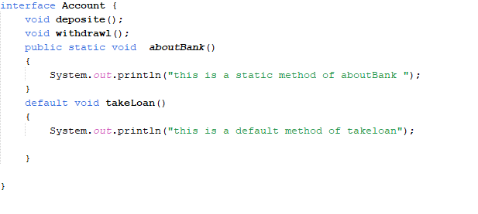
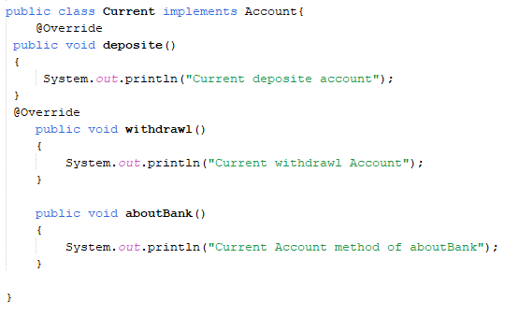
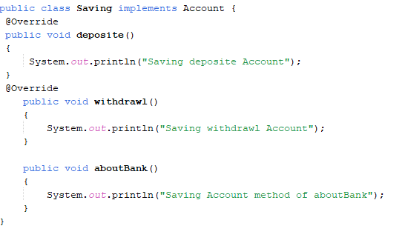
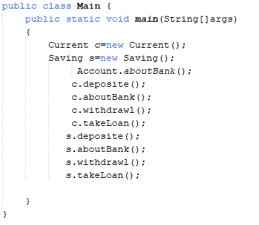
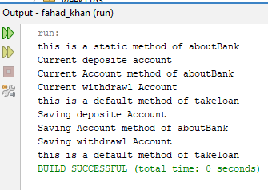

3# Create interfaces Bike and Scooty, both of which have two methods- offer() and details() (details() is default method). Create a new class BuySomething which implements both interfaces. To remove ambiguity, create a method details() in BuySomething class as well in which call the details() method of both interfaces. Call the methods of BuySomething class in main method.
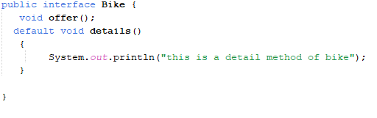
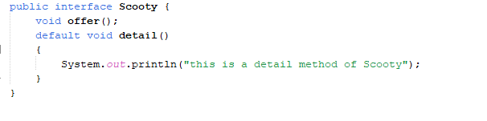
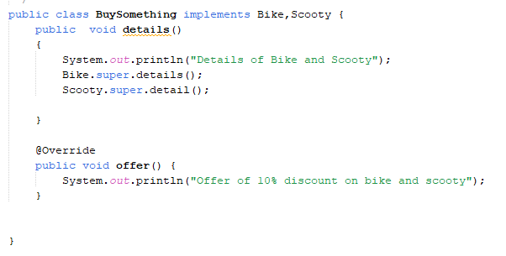
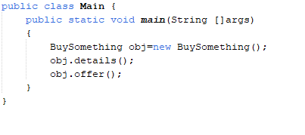
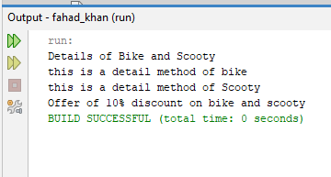
4# Create two interfaces Printer and Scanner, both having methods connect() and details() (details() is a default method). Create a class MultiFunctionMachine that implements both interfaces. In MultiFunctionMachine, override the details() method to resolve ambiguity and call the details() methods of both interfaces. Call all methods of MultiFunctionMachine in the main() method.
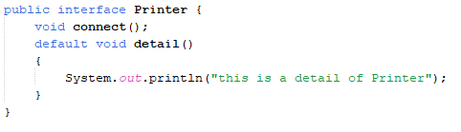
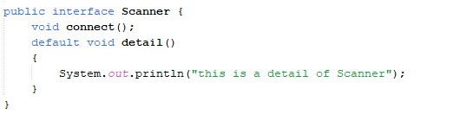
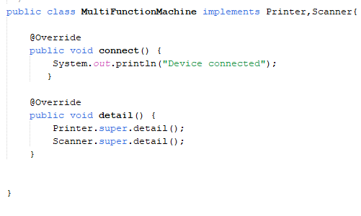
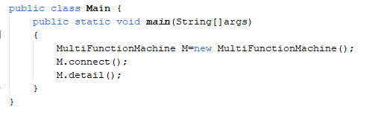
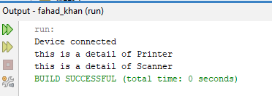
5# Create an interface Device with a method powerOn(). Create another interface SmartDevice that extends Device and adds a method connectWiFi(). Create a class SmartPhone that implements SmartDevice.
